**Aim:** Demonstrate virtualization by Installing Type -2 Hypervisor in your device, create and configure VM image with a Host Operating system (Either Windows/Linux).

**Step 1:** create a new virtual machine. Click on the installer disc image file(iso) and locate ubuntu operating system.

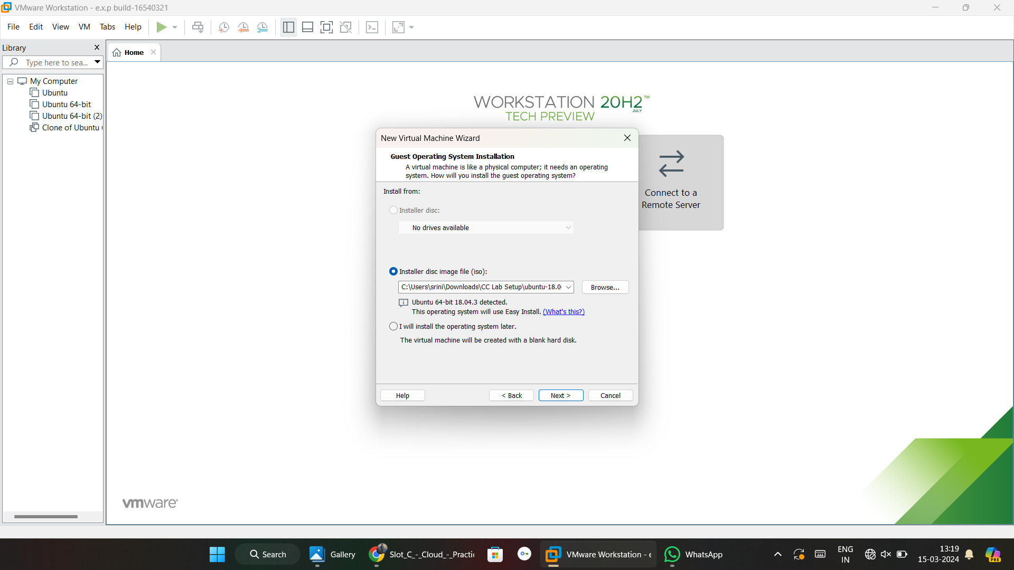

**Step 2:** Give login details for linux operating system.

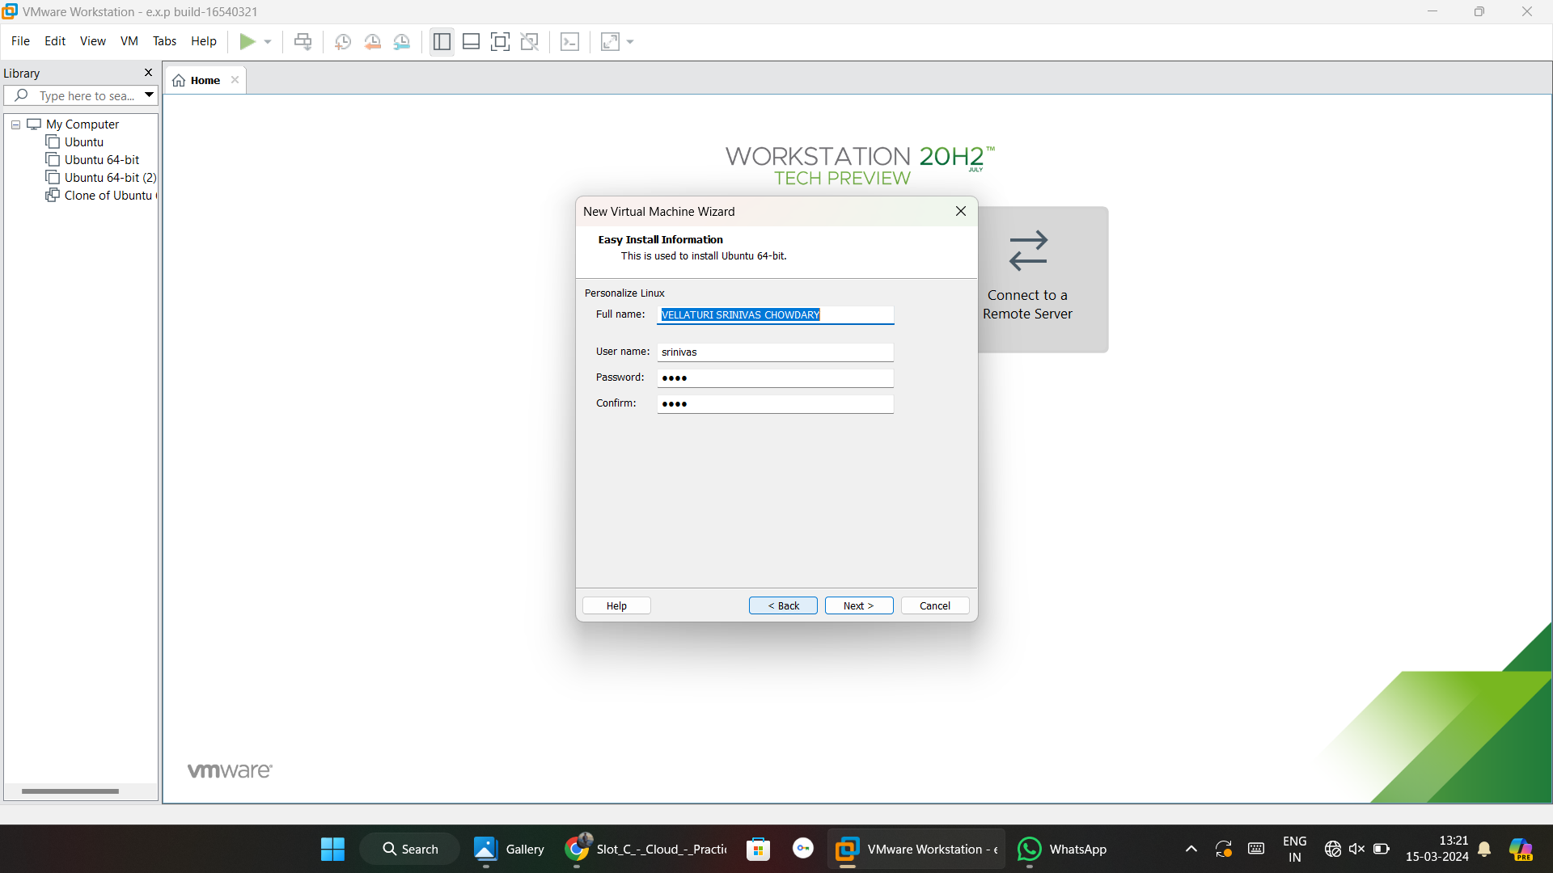

**Step 3:** Give virtual machine name and location.

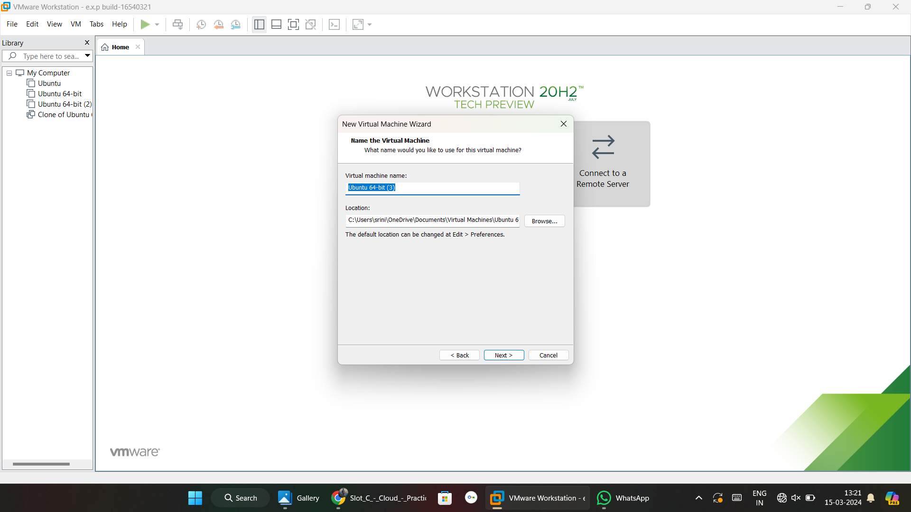

**Step 4:** Give the disk size.

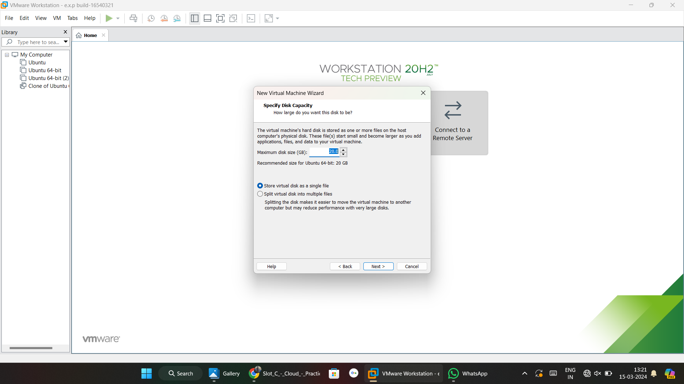

**Step 5:** Here we can see virtual machine created details.

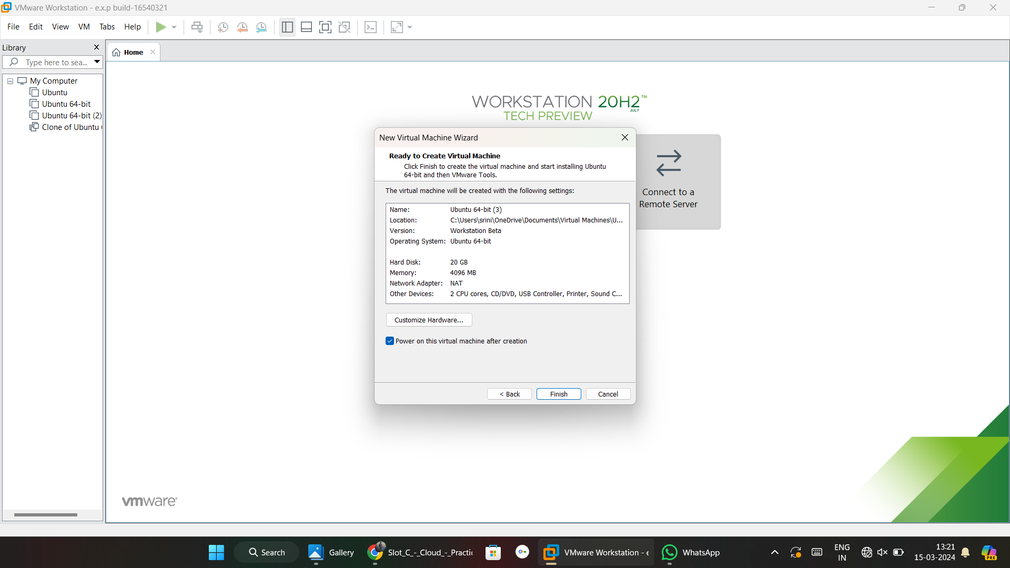

**Step 6:** virtual machine created and now it was booting.

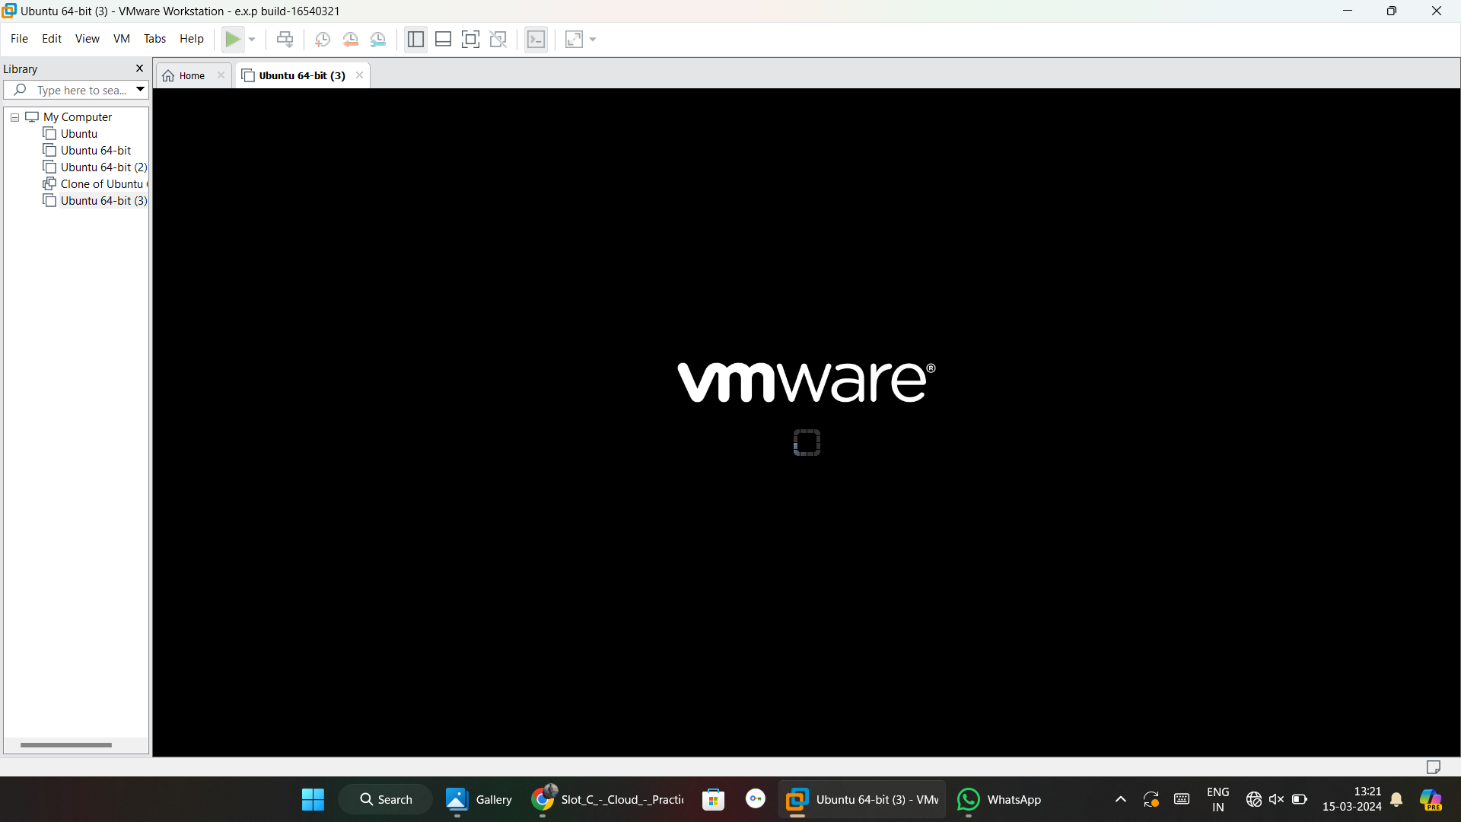

**Step 7:** finally linux os is created.

